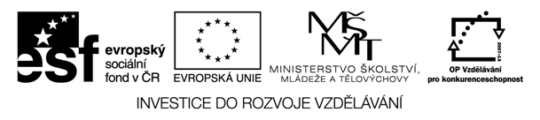

Název materiálu | Wimbledon
Druh materiálu | Pracovní list
Jazyk | Angličtina
Cílová skupina | žák
Autor | Mgr. Lucie Štatská

Activity 1 – before watching the play

What is Wimbledon?
Where is it?
What is it famous for?
Name some of the winners.

Match the names and nationalities:

Steffi Graf
Petra Kvitova
Pete Sampras
Andre Agassi
Roger Federer
Rafael Nadal
Martina Navratilova
Björn Borg
John McEnroe
Venus Williams
Maria Sharapova
Novak Djokovic

Spanish

American

Czech

Russian

German

Swiss

Serbian

Fill the right word into the text:

Oldest, Grand, grass, strawberries, championship, Queen, majors, white, tournament, England, advertisments, traditions
The Wimbledon __________________is the ____________ tournament in the world. It has been held at the All ________________Club in Wimbledon,London since 1877.
It is on of the four ________ Slam tenis tournaments, also called____________.
Wimbledon is the only ____________ still played on ___________ .
It has its special ________________, e.g. players can only play in _________clothes and spectators eat______________ with cream.
There are no ________________around the court.
The patron of the club is the ________________

What do you need to play tennis?

Explain:
Forty : love (40:0)
Set
Set point
Match point
Ball boy/ ball girl

Activity 2 – after seeing the play

Who were the two players?
What did they have on common?
Who killed one of the players? Why?
Who did you like the most and why?

Use phrases:
I think...
I agree...
I dont agree...
What do you think about....
In my opinion.......

Role play

Make a dialogue between a journalist and a Wimbledon winner/ loser. Try to make it interesting for your readers.

Activity 3
Draw a comic strip

Choose a part of the play and make a comic strip

