American and British English

American English |  | British English
elevator |  | 1 programme
gas |  | 2 flat
pants |  | 3 pavement
movie |  | 4 colour
apartment |  | 5 film
sidewalk |  | 6 grey
fall |  | 7 trousers
vacation |  | 8 lift
color |  | 9 centre
center |  | 10 holidays
gray |  | 11 petrol
program |  | 12 autumn

MOLLY MALONE

In Dublin's fair _______,
where the girls are so pretty
I first set my eyes on ________ Molly Malone
As she wheeled her wheel-barrow
Through streets broad and _________
_________ cockles and mussels, alive, alive-O!
Alive, alive-O! alive, alive-O!
_________ cockles and mussels, alive, alive-O!

She was a fish-monger,
but sure 'twas no wonder
For so were her father and _________ before
And they each wheeled their barrow
Through streets broad and _________
_________ cockles and mussels, alive, alive-O!
Alive, alive-O! alive, alive-O!
_________ cockles and mussels, alive, alive-O!
She died of a fever,
and no one could _________ her
And that was the end of sweet Molly Malone
But her ghost wheels her barrow
Through streets broad and _________
_________ cockles and mussels, alive, alive-O!
Alive, alive-O! alive, alive-O!
_________ cockles and mussels, alive, alive-O!

The United Kingdom of Great Britain and Northern Ireland

Complete these:
England + Wales + Scotland =
Great Britain + Northern Ireland =

Match these pieces of information:
Population Pound sterling
Area Union Jack
Capital 64,100,000
Currency Parliamentary constitutional monarchy
Government 243,610 km²
Flag English (Cornish, Irish, Scots,
Scottish Gaelic, Ulster-Scots, Welsh)
Head of the country London
Languages Queen

Places of interest:

Warwick Castle
Stonehenge
Stratford upon Avon
Hadrian´s Wall
Loch Ness
Edinburg castle
Windsor castle
Brighton
Winchester
Oxbridge
Lake District
Giant´s Causeway
Snowdonia

FLAG – the United Kingdom

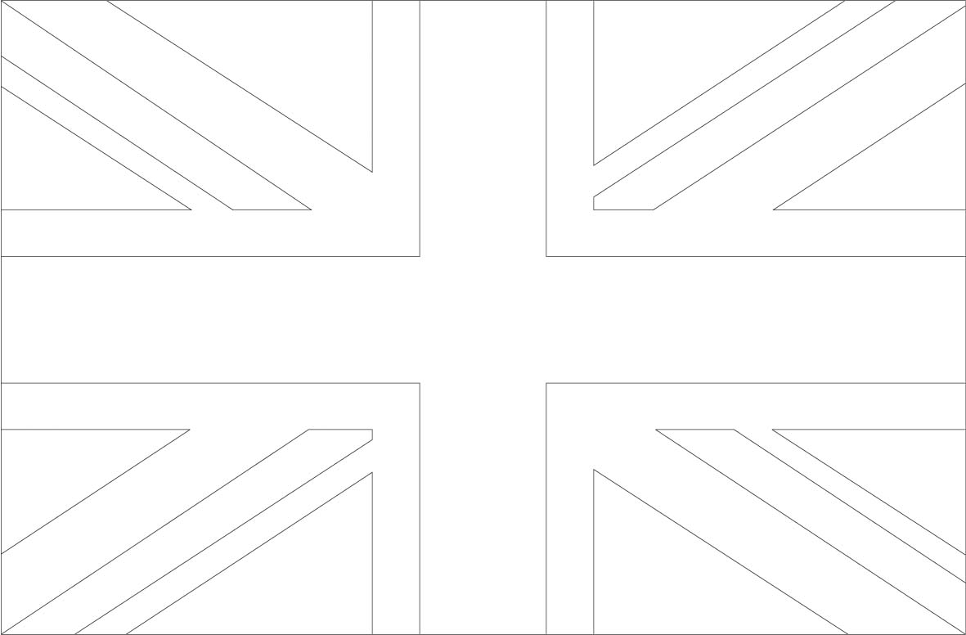

What is the flag of the United Kingdom called?

